Module Code: CSE202

Module Title: Object Oriented Analysis & Design with Java

Assignment Title: Banking System - Part A: System Documentation

Student Name: [Bakang Gabanthate]
Student Registration Number: [cse23-012]

Date of Submission: [19/09/25]
Lecturer/Tutor Name: [Lecturer's Name]

Part A: System Documentation
1. Requirements Elicitation
- Functional Requirements
- Customer Registration: The system shall allow new customers to register by providing personal details including first name, surname, physical address, email address, and phone number.
- User Authentication: The system shall enable registered customers to securely log in using their account number and PIN/password. The system shall also provide functionality for customers to change their PIN when desired.
- Account Management:
  - The system shall allow authenticated customers to open new accounts of different types (Savings, Investment, or Cheque)
  - The system shall enforce specific business rules for each account type:
    - Savings Account: Does not permit withdrawals, accrues 0.05% monthly interest
    - Investment Account: Requires a minimum initial deposit of BWP 500.00, allows withdrawals, accrues 5% monthly interest
    - Cheque Account: Restricted to employed customers (requires employer name and address details), allows both deposits and withdrawals
- Transaction Processing:
  - The system shall enable customers to deposit funds into any of their accounts
  - The system shall allow customers to withdraw funds from eligible accounts (Investment and Cheque accounts)
  - The system shall provide balance inquiry functionality for all account types
- Interest Calculation: The system shall automatically calculate and apply monthly interest to Savings and Investment accounts based on their respective interest rates and current balances
- Session Management: The system shall provide a secure logout mechanism for authenticated customers

- Non-Functional Requirements:
- Security: Customer PINs/passwords must be stored using secure encryption (hashed and salted). All transactions require authentication. The system must prevent unauthorized access to customer data through proper access control measures.
- Usability: The User Interface must be intuitive, requiring minimal training for customers with basic computer literacy. Navigation should be consistent and predictable throughout the application.
- Performance: Common operations (login, balance inquiry, deposit transactions) must complete within acceptable response times (under 2 seconds for most operations).
- Reliability: The system must maintain stability during error conditions (insufficient funds, invalid input formats) without crashing, providing meaningful error messages to users.
- Maintainability: The codebase must be well-structured with comprehensive comments, adhering to Object-Oriented Principles to facilitate future enhancements and troubleshooting.

- Structural UML Modelling

2.1. System Use Case Diagram
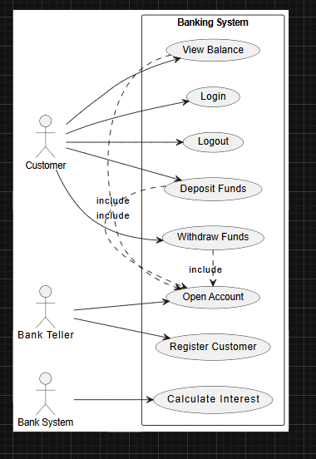

2.2. Class diagram
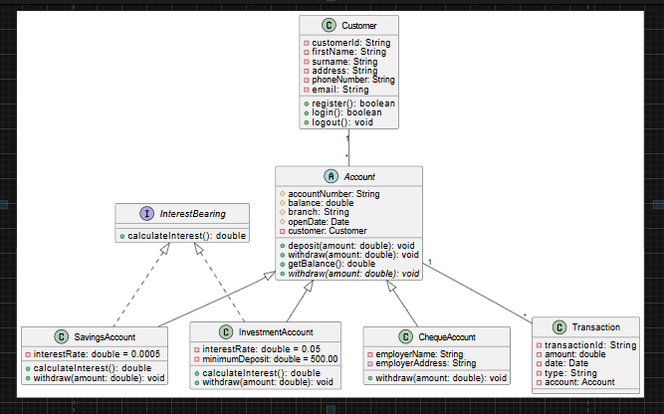

- Behavioural UML Modelling)

3.1. Login and Deposit Sequence Diagrams:
LogIn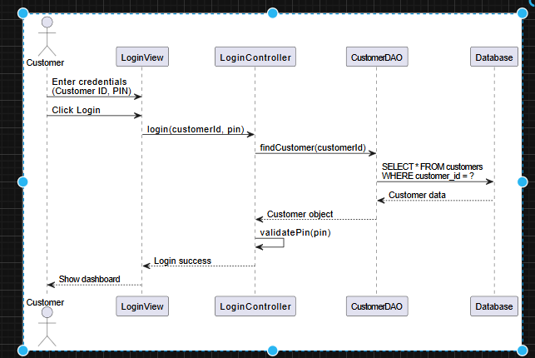
Deposit
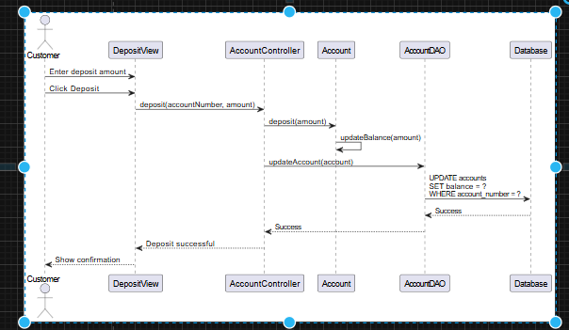
3.2. State Diagram:
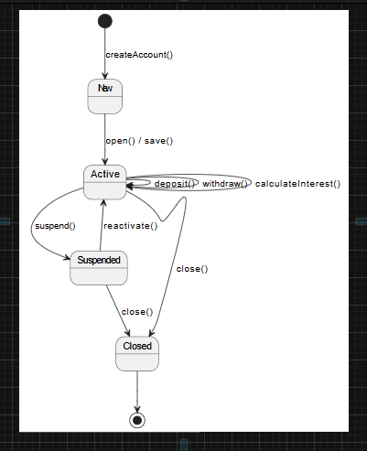

Meeting record appendix
Interviewer: []
Interviewee: []
Date: []
Purpose: To elicit functional and non-functional requirements for the new Banking System
Key Points Discussed:
- Q: What are the primary account types you need to support?
  - A: We require three distinct account types: Savings, Investment, and Cheque. Each has specific rules governing account opening, withdrawal permissions, and interest calculation. This differentiation is fundamental to our business model.
- Q: How would you prioritize security concerns?
  - A: Security is our highest priority after regulatory compliance. Customer trust depends on it. PINs must be protected with industry-standard encryption, and customers must never be able to access another customer's data.
- Q: Should customers be restricted to a single account?
  - A: No, we encourage multiple account relationships. A customer might maintain a Savings account for long-term goals while using a Cheque account for daily transactions and salary deposits.
- Q: What are your requirements for interest calculation and application?
  - A: Interest must be calculated automatically and added to account balances at monthly intervals. The system must apply different rates for Savings (0.05%) and Investment (5%) accounts accurately.
Conclusion: The system must prioritize security while maintaining usability, accurately implementing the specific business rules for each account type, including automated monthly interest calculations based on account type and balance.

